Dodford Village Hall
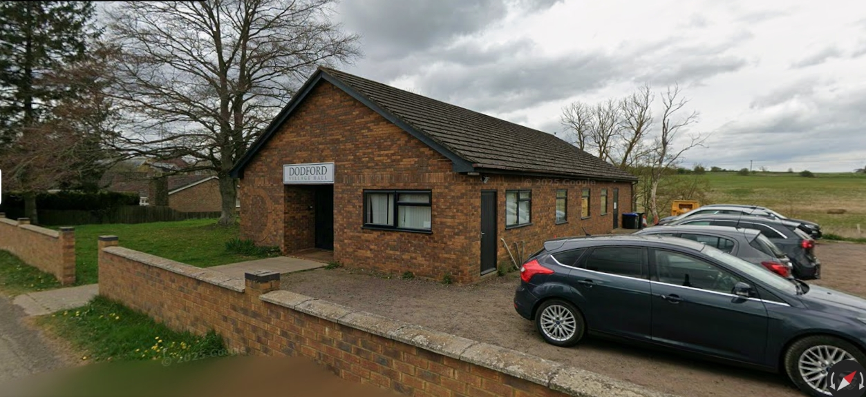

Dodford Village Hall is a focal point for the residents of Dodford village and the surrounding Parish, as well as also being available for private hire for a maximum of 100 guests.
For enquiries, or to make a booking, please call 01327 341358. For enquiries about events currently hosted in the village hall, please contact the event organiser, not the administrators of the hall.
The village hall is located on Brockhall Road, close to the centre of the village; postal address:- Dodford Village Hall, Brockhall Road, Dodford, Northants. NN7 4SY.
